Physical Sun and Sky
Go to the Render Setting button to access the page to create Physical Sun and Sky. MAKE SURE RENDERER is set to Mental Ray.
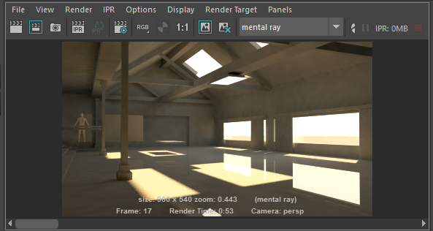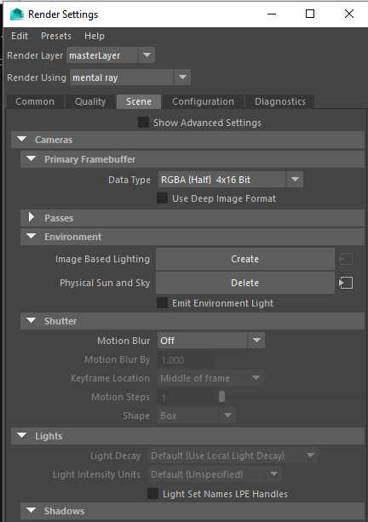
Click Create in the render settings menu under the Tab: Scene/Cameras/Environment. Once you do, it will now say Delete
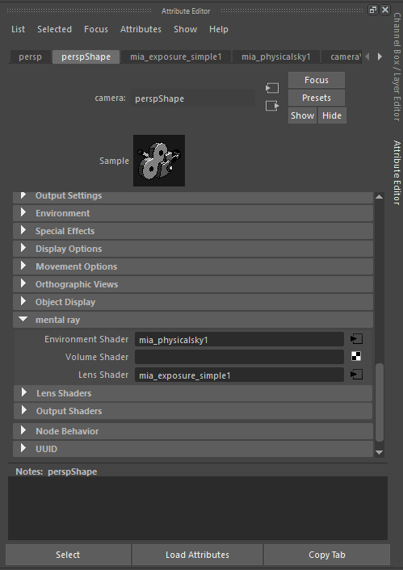
Select the Perspective Camera and in the perspShape settings in the attribute editor go to Mental Ray and in the Lens Shader attribute, click on the checkerboard to the right and select: mia_exposure_simple in the create node menu.
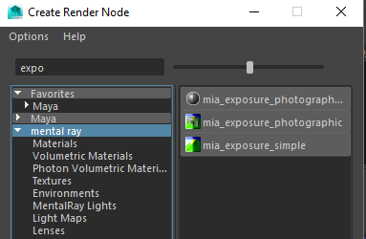
MIA_Exposure_Simple (Plugged into the camera: Mental Ray/Lens Shader)

In the Hypershade view, pick the Utilities tab and you will see the utility nodes that control the Physical Sun and Sky.
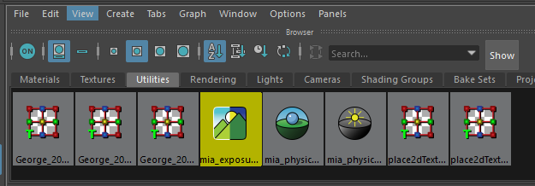
MIA_Exposure_Simple
Pedestal: Affects the darks/blacks in the scene. Lowering the Pedestal makes the blacks in the scene darker
Gain: Overall brightness (raise for brighter, lower for less bright_
Knee and Compression: control the Highlights
Change the angle of the sun to change the color of the sky relative to sunset or afternoon light
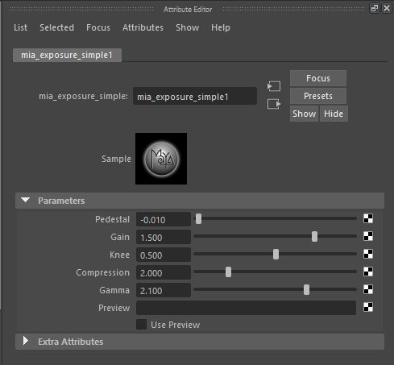

CONTROLS FOR SUN & SKY:
MIA_physicalsky
Multiplier: overall brightness
Haze: overcast sky (0 to 10)
Red/Blue Shift: warms or cools scene (-1 =Blue, 1 = Red)
Saturation: adds or removes saturation
Horizon Height & Blur: controls the horizon created by Physical Sun and Sky
Ground Color: changes color of horizon
Night Color: changes color of sky opposite of setting sun
Sun Disk Intensity & Size: controls sun
Sun Glow Intensity: adjusts post-process glow effect on the sun
